PlasmaGraph
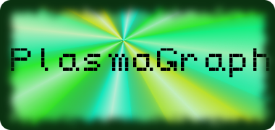
Software Design Description



By: Plasma Visualization Group

Polytechnic University of Puerto Rico
Electrical & Computer Engineering and Computer Science Department
Fall – Winter 2013
CS 4200: Computer Science Senior Project
Professor: Luis A. Ortiz
Version: SPMP r1
Members:
Daniel E. Quintini Greco [CS - # ]
Gerardo A. Navas Morales [CS - # 69615]

Revision Chart
- Tuesday, January 21, 2014 – r1 – First version of document. No diagrams, just Introduction. Using SPMP as template.
- Thursday, January 23, 2014 – r2 – Second version of document; added diagrams made up to this date. Provided better structure and removed all mentions of SPMP, including Table of Contents.

Preface

Table of Contents
Section Page
1. Introduction -
1.1. Purpose -
1.2. Scope -
1.3. Notes -

2. Main System -

3. Data Importing and Processing -

4. Graph Creation -

I. Introduction
- Purpose
This document will detail the design of the product in terms of programming internals. It will take advantage of various UML 2.5-specified diagrams in order to present the program flow in a graphical manner.
- Scope
PlasmaGraph is a data graphing program made in Java, and is designed to take files of certain formats (See the SRS for the specific formats.), turn them into usable data, and graph them based on certain user-provided criteria. To that end, this document describes how the product will be designed; it details the organization of the individual files that contain the programing code, the various classes that exist in the program, and how the functions of each of these classes act and interact to create the functionality requested by the Client. The graphical nature of this document makes it a valuable tool in understanding the processes
- Notes
This document is a work in progress; as such, the order of the diagrams is not indicative of its order on the final product.

- Main System

- Data Import

- Graph Creation

